Directions: It’s been a while since covered a variety of topics from this course. This review worksheet covers some (not necessarily all) of the topics that we have learned. DO NOT take this review to be a copy of the final exam. Be sure to look over the Final Exam Study Guide and take heed of the other recommendations for preparing for the file. Remember that many of these problems are still Challenge Problems and therefore it is not expected that you might know how to answer each of these questions immediately.

- Compute each of the following limits.

- (where a and b are positive real numbers).

- . (Hint: Think about the form of the limit and what properties you might be able to take advantage of to get this limit into a more useful form)

- Let c be an arbitrary real number. Give examples of differentiable functions f and g satisfying:
and

Suppose we simply let . Clearly and

- Give the definition of what it means for a function to be continuous at a. Give an example of a function which is continuous at all x. Give an example of a function which has a removeable discontinuity at . Give an example of a function which has a jump discontinuity at .

A function is continuous at if .

is a function which is continuous at all values of x.

is a function which has a hole (removable discontinuity) at .

is a function which has a jump discontinuity at

- Give the definition of . Use the definition to show that if the then .

provided that this limit exists.

If then
- Consider the following three functions.
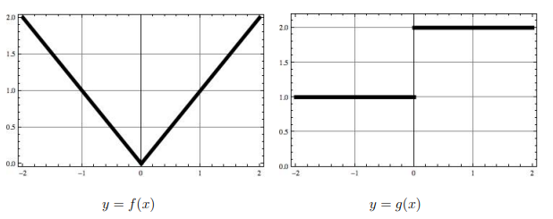

- Which of the functions are continuous?

We see that is continuous and we know that is continuous by the FTCP1.
is not continuous at .

- Which of the functions are differentiable?

We see that and are not differentiable at .
We know that is differentiable by the FTCP1.

- What is equal to?

We know that

- What is equal to?
We know that

- What is

We calculate that
- What is equal to?

We calculate this value geometrically by looking at the graph of

- What is equal to?

We calculate that and so

- Consider the equation . Find .

- Find a formula for the function , given the information that f is a continuous function and that .
If these functions are indeed equal then the derivative of each side must still be equal. We calculate that
- Two vertical poles, one 4m high and the other 16m high, stand 15m apart on a flat field. You must support both poles by running rope from one spot on the ground to the top of each post. What spot on the ground should you choose, in order to use the smallest amount of rope? (First stop and think: what kind of problem is this? Related rates? Optimization? Differential/linear approximation? etc.)
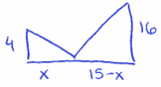
We measure the length of the rope used as
We calculate

We see that is never undefined.
when

Since is bounded between we simply check

We see that the smallest length of rope occurs when . Therefore, we should choose the spot on the ground that is 3ft to the right of the shorter poll.

- A Ferris wheel with a radius of 10m is rotating at a rate of one revolution every 2 minutes. How fast is a rider rising when his seat is 16m above the ground level? (First stop and think: what kind of problem is this? Related rates? Optimization? Differential/linear approximation? etc.)

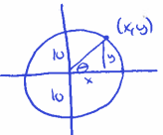
We know that .
We want when .

We relate the necessary variables with the equation .
We calculate

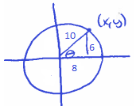
We evaluate this derivative when the rider is 16m above ground level.

- ACME Inc. has determined that the company profit determined by a function where x represents a special unique machine setting variable whose true meaning is only known by company higher ups. It is also known thathas an absolute maximum at its only critical point. Approximate the value of this critical point using Calculus.

We know that must have a critical point when since we know that is never undefined.
So, we are looking for a root of . We will proceed using Newton’s method.
We calculate that .

We make our initial guess as .
- Give an example where and are increasing at but is decreasing at for some value of a.

Let and . Notice that both of these functions are increasing at all values of x. However, is not increasing for all values of x, specifically it is decreasing for all values of .

So, if we let , then we can say that f and g are increasing at , but is decreasing at .

- Consider the function . Answer the following question without the use of a calculator.
- How does f behave as ?

We calculate that

- Where are the critical points of f ? Where is f increasing, decreasing?

when
is never undefined.
$$+$$
$$-$$
$$MAX$$

is decreasing on
is increasing on

- Determine the inflection points of f and where f is concave up and concave down.

when
is never undefined.

$$+$$
$$-$$
$$+$$
is concave down on
is concave up on

has inflection points of

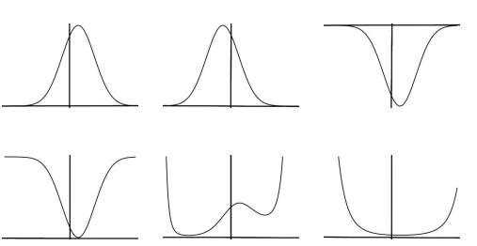
- Which of the following graphs is likely a graph of f ?

- Let f be a function whose second derivative is continuous for all real numbers. Show that if is the minimum for f and the maximum for f then for some c between 1 and 3. Here is the graph of a sample function with these properties.

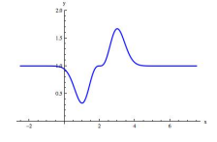
We know that if there is a minimum at , then and
if there is a maximum at , then . Since is continuous for all real numbers it must be continuous on and therefore, by the IVT, there must exist a value c within such that .

- Consider the integral .
- Sketch the net area represented by the integral and compute it using geometry.
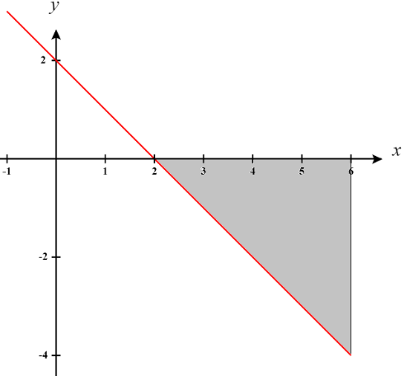

The area of the region is .
Therefore,

- Compute the integral using the Fundamental Theorem of Calculus.

- Compute the integral by using the definition of definite integral.

We use the definition of the definite integral to set up the following:
Width of Rectangles | Right Endpoints | Height of Rectangles
Therefore, we can say that . We then calculate:

- Calculate each of the following.

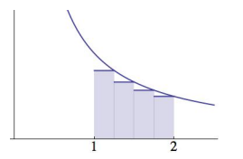
- The following is a graph of with some shaded rectangles.
- Explain how the diagram leads to the inequality .

We see that the area of the rectangles provide an under-approximation for the area under on the interval .

Notice that the sum total of the area of the rectangles is
Also note that the actual area under the curve is given by .
Since the approximation is an underestimate, we have established that

- Explain why .

We will use right endpoints, to setup the limit definition of the integral of .
We use the definition of the definite integral to set up the following:
Width of Rectangles | Right Endpoints | Height of Rectangles
Therefore, we can say that . We then calculate:

So, since know that this means that .
- Let where h and b represent arbitrary positive real numbers.

- Sketch the graph of being sure to label the x-intercepts and y-intercepts.

The y-intercept of a function occurs when , therefore the y-intercept for f is .
The x-intercept(s) of a function occurs when , therefore the x-intercepts for f are
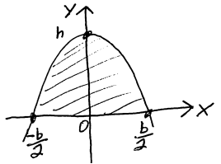
.

Therefore, a sketch of would look like the picture at the right.

- Determine the area of the finite region bounded by the graph of and the x-axis. Fully simplify your answer.

We calculate

Thus, the area of a parabolic arch is .

- Suppose that , is continuous, and , what is the value of ?
We know that and since we are given that this means that .
We also are told that and therefore

- A point is moving along the x-axis with acceleration at time t. If its initial velocity is 27, how far does the particle move from time to time ?

We know that .
This implies that . Since we know that we have that .
Therefore,
We are interested here in finding the total distance traveled by the particle on . Therefore, we compute

- A patient is experience blood loss at a rate of pints per minute at time t (as t increases, the blood loss slows due to decreased pressure). Approximately how long before the patient loses 3 pints of blood after ?

We need to find a value of x such that . This implies that

- During a race, the velocities of two cars were plotted, and . After the first hour, car A was ahead of car B but car B finished the race in 2 hours, which was 15 minutes (0.25 hours) ahead of car A. From this information we can say… (fill in in the space)

